Experiment 5
Aim : To study File Processing
Theory:
In C++, files are mainly dealt by using three classes fstream, ifstream, ofstream available in fstream headerfile.
ofstream: Stream class to write on files
ifstream: Stream class to read from files
fstream: Stream class to both read and write from/to files.
Now the first step to open the particular file for read or write operation. We can open file by
1. passing file name in constructor at the time of object creation
2. using the open method
For e.g.

Open File by using constructor
ifstream (const char* filename, ios_base::openmode mode = ios_base::in);
ifstream fin(filename, openmode) by default openmode = ios::in
ifstream fin(“filename”);

Open File by using open method
Calling of default constructor
ifstream fin;

fin.open(filename, openmode)
fin.open(“filename”);

Modes :
MEMBER CONSTANT | STANDS FOR | ACCESS
in * | input | File open for reading: the internal stream buffer supports input operations.
out | output | File open for writing: the internal stream buffer supports output operations.
binary | binary | Operations are performed in binary mode rather than text.
ate | at end | The output position starts at the end of the file.
app | append | All output operations happen at the end of the file, appending to its existing contents.
trunc | truncate | Any contents that existed in the file before it is open are discarded.
Default Open Modes :
ifstream | ios::in
ofstream | ios::out
fstream | ios::in | ios::out

1. #include<iostream>
#include<iomanip>
#include<fstream>
using namespace std;
int main(){
int num;
fstream f1,f2,f3;
f1.open("File1",ios::in|ios::out|ios::trunc);
f2.open("File2",ios::in|ios::out|ios::trunc);
f3.open("File3",ios::in|ios::out|ios::trunc);
cout<<"Enter 5 numbers in a file"<<endl;
for(int i=0;i<5;i++){
cin>>num,f1<<num<<endl;
}
cout<<"Enter 3 numbers in file\n";
for(int i=0;i<3;i++){
cin>>num,f2<<num<<endl;
}
long a,b;
f1.seekg(0);
f2.seekg(0);
f1>>a;
f2>>b;
while(!f1.eof()){
f3<<a<<endl;
f1>>a;
}
while(!f2.eof()){
f3<<b<<endl;
f2>>b;
}
cout<<"....................................................."<<endl;
f3.seekg(0);
int arr[8];
int i=0;
while(f3>>arr[i]){
i++;
}
f3.close();
for(int k=0;k<i;k++){
cout<<arr[k]<<endl;
}
for(int j=0 ;j<i;j++){
for(int k=0;k<i-1-j;k++){

if(arr[k+1]<arr[k]){
int t=arr[k+1];
arr[k+1]=arr[k];
arr[k]=t;
}
}
}
f3.open("File3",ios::trunc|ios::out|ios::in);
for(int k=0;k<i;k++)
f3<<arr[k]<<endl;
cout<<"in ascending order\n";
f3.seekg(0);
while(f3>>a){
cout<<a<<"\t";
}
f1.close();
f2.close();
f3.close();
}

OUTPUT:

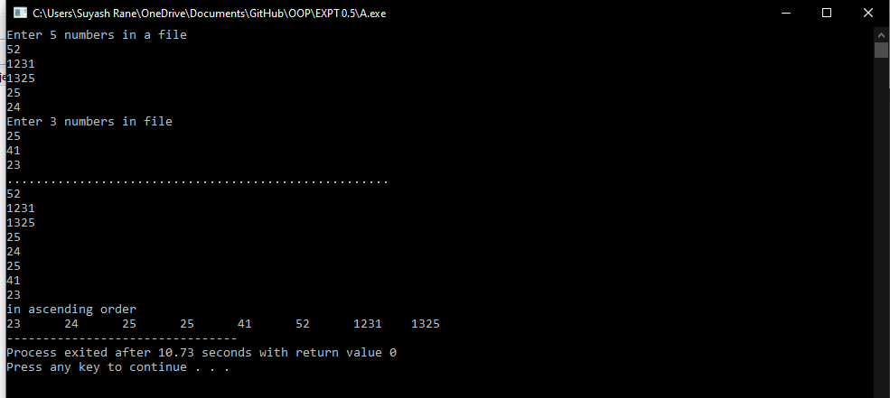

2. #include <iostream>
#include <fstream>
#include <cstring>
#include <iomanip>
#include <conio.h>
using namespace std;
class Directory
{
char name[40];
long long int tel_num;
public:
void getdata();
void showdata();
char *get_name()
{
return name;
}
void update(char *nm,long long int telno)
{
tel_num=telno;
strcpy(name,nm);
}
};
void Directory :: getdata()
{
cout<<"Enter Name : ";
cin.ignore();
cin.getline(name,40);
cout<<"Enter Phone No :" ;
cin>>tel_num;
}
void Directory:: showdata()
{

cout<<setw(20)<<left<<"name"<<setw(20)<<right<<"phone number"<<endl;
cout<<setw(20)<<left<<name<<setw(10)<<right<<"-"<<tel_num<<endl;

}
int main()
{
Directory user;
fstream file;
file.open("PHONE.txt", ios::in | ios::out | ios:: trunc);
char ch,nm[20];
long long int telno;
int choice,found=0, cnt=0;
while(1)
{
cout<<"1) Add New Record\n";
cout<<"2) Display All Records\n";
cout<<"3) Update Telephone No\n";
cout<<"4) Exit.\n";
cout<<"Make your choice : ";
cin>>choice;
switch(choice)
{
case 1 :
user.getdata();
cin.get(ch);
file.write((char *) &user, sizeof(user));
break;
case 2 :
file.seekg(0,ios::beg);
cout<<"\n"<<setw(10)<<"NAME"<<setw(20)<<"TELEPHONE NO."<<endl;
while(file.read((char *) &user, sizeof(user)))
{
if(!file.eof())
user.showdata();
}
file.clear();
break;
case 3 :
cout<<"\n\nEnter Name : ";
cin>>nm;
file.seekg(0,ios::beg);
found=0;
while(file.read((char *) &user, sizeof(user)))
{
cnt++;
if(!strcmp(nm,user.get_name()))
{
found=1;
break;
}
}
file.clear();
if(found==0)
cout<<"\n\n---Record Not found---\n";
else
{
int location = (cnt-1) * sizeof(user);
cin.get(ch);
if(file.eof())
file.clear();
cout<<"Enter New Telephone No : ";
cin>>telno;
file.seekp(location);
user.update(nm,telno);
file.write((char *) &user, sizeof(user));
file.flush();
}
break;
case 4 :
file.close();
goto end;
default: cout<<"\aPlease make a correct choice!";
}
cout<<"\n\n\n";
}
end: exit(1);
return 0;
}

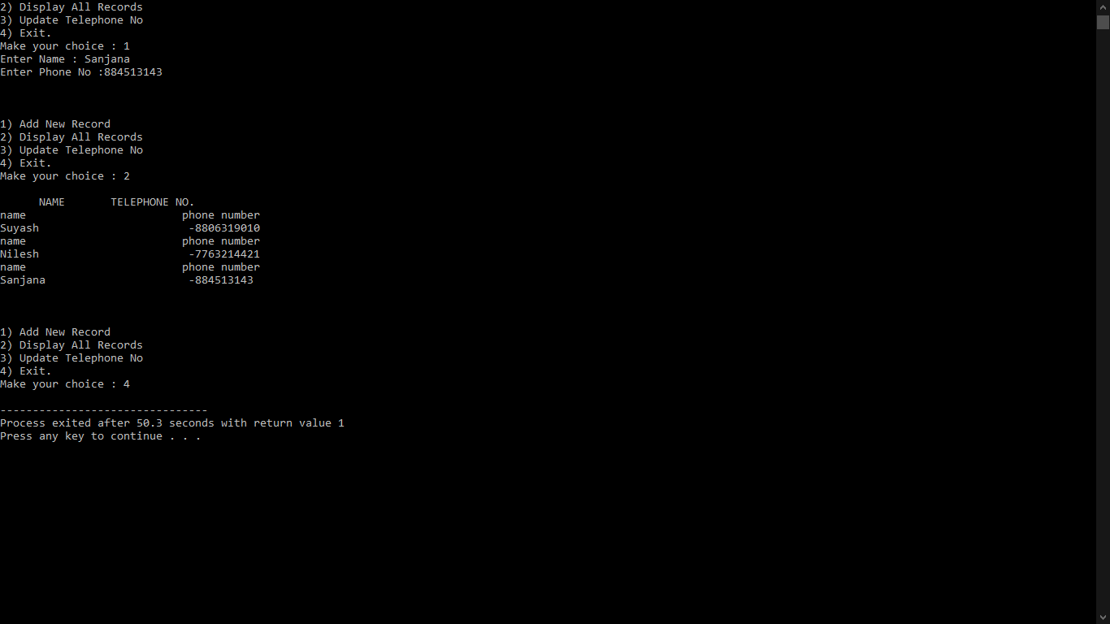
3. #include<iostream>
#include<iomanip>
#include<fstream>
#include<string.h>
using namespace std;
class Student{
char name[100],branch[100],address[100];
long long int rollno;
public:
Student()
{
strcpy(name,"");
strcpy(branch,"");
strcpy(address,"");
rollno=0;
}
void getinfo(){
fflush(stdin);
cout<<"Enter your name"<<endl;
gets(name);
cout<<"Enter branch"<<endl;
gets(branch);
cout<<"Enter addresss"<<endl;
gets(address);
cout<<"Enter roll_no"<<endl;
cin>>rollno;
}

void display()
{

cout<<left<<setw(15)<<"name"<<setw(15)<<"branch"<<setw(25)<<"address"<<setw(15)<<"roll no"<<endl;
cout<<left<<setw(15)<<name<<setw(15)<<branch<<setw(25)<<address<<setw(4)<<right<<rollno<<endl;

}
char *getName()
{
return name;
}
long long int getRn()
{
return rollno;
}

};
int main()
{
Student *s[100];
int n=0;
while(1){
int c;
cout<<endl<<setw(4)<<right<<"1-"<<left<<"Add Students data";
cout<<endl<<setw(4)<<right<<"2-"<<left<<"Search Students data";
cout<<endl<<setw(4)<<right<<"3-"<<left<<"Update Students data";
cout<<endl<<setw(4)<<right<<"4-"<<left<<"Exit"<<endl;
cin>>c;
switch(c){
case 1:{

s[n] = new Student();
s[n]->getinfo();

ofstream F(s[n]->getName(),ios::trunc|ios::binary);
F.clear();

F.write((char *)&(*s[n]),sizeof(*s[n]));
s[n]->display();
n++;
break;
}
case 2:
{
Student temp;
char name[100];
cout<<"Enter name"<<endl;
cin.ignore();
gets(name);
ifstream F(name);
if(F.good()){

F.read((char *)&temp,sizeof(temp));
temp.display();

}
else{
cout<<" this stdudent is not there in our record"<<endl;
}
break;
}
case 3:
{

char name[100];
long long int roll;
cout<<"Enter rollno"<<endl;
cin>>roll;
int i=0;
for(i=0;i<n;i++)
{
if(s[i]->getRn()==roll)
{
strcpy(name,s[i]->getName());
break;
}
}

ofstream F(name,ios::trunc);
if(F.good()){
cout<<"You may change any detail except Name"<<endl;
s[i]->getinfo();
F.write((char *)&(*s[i]),sizeof(*s[i]));

rename(name,s[i]->getName());
}
else{
cout<<"No such Student has been recorded"<<endl;
}

break;
}
default:
exit(0);

}
}
}

OUTPUT:

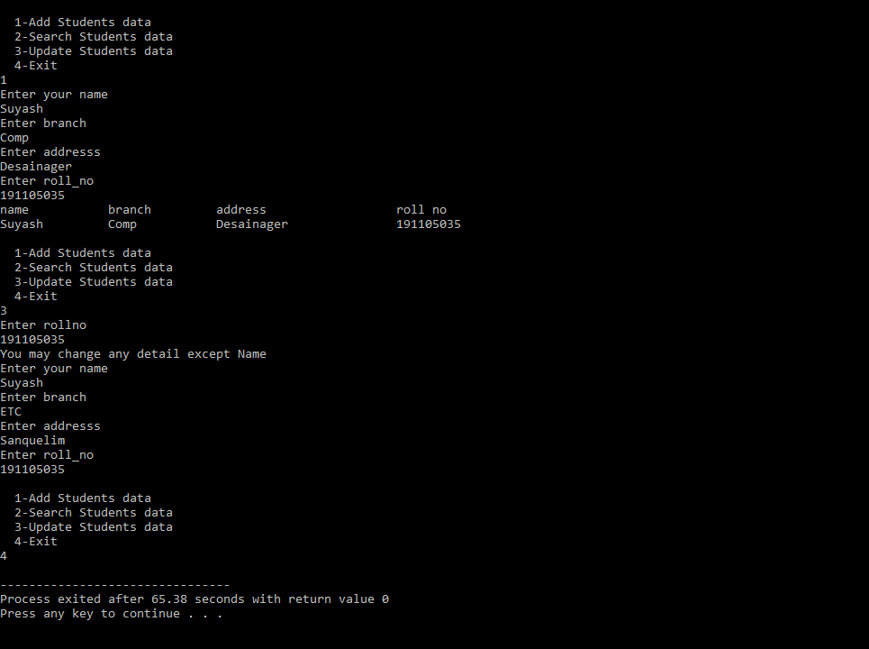

CONCLUSION:
- Handling datathough files is much easier and convenient.
- The open() function can be used to open multiple files that use the same stream object.
- If we do not specify the second argument of open() function, the default values specified in prototype of these class member functions uses while opening the file.
- To open an existing file for updating without losing its original contents we need to open it in an append mode
- The fstream class does not provide a mode by default and therefore we must provide the mode explicitly when using an object of fstream class.
- We can specify more than one file mode using bitwise operators.

